Botanical Sciences 97 (2): 250-259. 2019 Received: July 18, 2018, accepted: February 6, 2019

DOI: 10.17129/botsci.2143 On line first: April 10, 2019



*Taxonomy and Floristics/Taxonomía y florística*

On the identity of two Mexican species of *Ageratina* (Eupatorieae, Asteraceae): *A.* *grandifolia* and *A. rivalis*

Sobre la identidad de dos especies mexicanas de *Ageratina* (Eupatorieae, Asteraceae): *A. grandifolia* y *A. rivalis*

Oscar Hinojosa-Espinosa1,2, José Luis Villaseñor1,*, and Enrique Ortiz1

* Departamento de Botánica, Instituto de Biología, Universidad Nacional Autónoma de México, Ciudad de México, México.

2 University of California Davis, Davis, California, USA.

* Corresponding author: vrios@ib.unam.mx

**Abstract**

**Background:** *Ageratina*, with 167 species, constitutes the most diverse genus of the Mexican Asteraceae and the sixth most diverse of thevascular plants in Mexico. The taxonomy of the genus is complex due to its number of species and the numerous inadequately delimited taxa or with intricate and confusing nomenclature. In addition, little known species have sometimes remained under the synonymy of another dif-ferent species, as in the case of *A. rivalis*, which has been considered as a synonym of *A. grandifolia*.

**Question:** Is it possible to recognize*Ageratina rivalis*as a distinct species of*A. grandifolia*by critically analyzing its circumscription, no-menclature and geographical distribution?

**Taxon:** *Ageratina grandifolia*and*A. rivalis*.

**Study site:** Mexico.

**Method:** A thorough review of herbarium specimens, field material, descriptions and geographic distribution of the species was made tocontrast them.

**Results:** Several differences exist in the morphology and geographical distribution of*Ageratina rivalis*and*A. grandifolia*. Descriptions,pictures, distribution maps, synonymy and a key to distinguish them from similar species are provided. The presence of *A. grandifolia* in Mexico City is also documented. Lectotypes are designated for *Eupatorium conspicuum, E*. *conspicuum* var. *pueblense*, *E*. *grandifolium*, and *E*. *rivale*.

**Conclusions:** Morphology and geography support the distinction between*A*.*grandifolia*and*A*.*rivalis*. However, further research is desir-able to corroborate or refute this statement, and especially to clearly circumscribe several similar species that seem to be related. This work contributes to a better understanding of the taxonomy and biogeography of the genus *Ageratina* in Mexico.

**Key words:** lectotype designation, invasive plants, medicinal plants, ornamental plants, taxonomy.

**Resumen**

**Antecedentes:** *Ageratina*, con 167 especies constituye el género más diverso de las Asteraceae mexicanas y el sexto más diverso de las plantasvasculares en México. Su taxonomía es compleja debido al gran número de especies y a la existencia de taxones inadecuadamente delimitados o con nomenclatura confusa. Además, especies poco conocidas han permanecido bajo sinonimia de otras especies, como ocurre con *A*. *rivalis*, la cual ha sido considerada como sinónimo de *A*. *grandifolia*.

**Pregunta:** ¿Es posible reconocer a*Ageratina rivalis*como una especie distinta de*A. grandifolia*analizando críticamente su circunscripción,nomenclatura y distribución geográfica?

**Especies de estudio:** *Ageratina grandifolia*y*A. rivalis*.

**Sitio de estudio:** México.

**Métodos:** Se hizo una minuciosa revisión de ejemplares de herbario, material en campo, descripciones y distribución geográfica de las especiespara contrastarlas.

**Resultados:** Se encontraron diferencias morfológicas entre*A*.*rivalis*y*A. grandifolia*. Se proporcionan descripciones, fotos, mapas de distri-bución, sinonimia y una clave para distinguirlas de especies parecidas. También se documenta la presencia de *A*. *grandifolia* en la Ciudad de México. Además, se designan lectotipos para *Eupatorium conspicuum, E*. *conspicuum* var. *pueblense*, *E*. *grandifolium* y *E*. *rivale*.

**Conclusiones:** Tanto su morfología como su geografía apoyan el reconocimiento de*Ageratina grandifolia*y*A*.*rivalis*como especies distintas.Sin embargo, es deseable que se realicen estudios adicionales que puedan corroborar o refutar este postulado, especialmente para circunscribir mejor varias especies similares que al parecer están relacionadas. Este trabajo contribuye a una mejor comprensión de la taxonomía y bio-geografía del género *Ageratina* en México.

**Palabras clave:** Designación de lectotipos, plantas invasoras, plantas medicinales, plantas ornamentales, taxonomía.



This is an open access article distributed under the terms of the Creative Commons Attribution License CCBY-NC (4.0) international. https://creativecommons.org/licences/by-nc/4.0/



250

On the identity of two Mexican species of *Ageratina*

*Ageratina* Spach is the largest genus of the Mexican As-teraceae and the sixth largest genus of Mexican vascular plants (Villaseñor 2016, 2018). It comprises 167 species in Mexico, which are common members of humid mountain and conifer forests, as well as dry tropical forests and xero-phytic shrublands of the country. They are mostly perennial or suffruticose herbs to large shrubs, with opposite, simple leaves, discoid heads and a pappus of persistent capillary bristles. The genus was resurrected from the synonymy of the traditional broad concept of *Eupatorium* L. by King & Robinson (1970). Because *Eupatorium* in its broad sense is a polyphyletic assemblage of several hundred species, it was narrowed to a more natural group of about 48 species, as summarized in King & Robinson (1987). Since then, prelimi-nary phylogenetic analysis based on morphology (Bremer *et al.* 1994) and DNA sequences (Schilling *et al*. 1999, Ito *et al*. 2000, Robinson *et al*. 2009) have supported the nar-row circumscription of *Eupatorium* and the resurrection of *Ageratina*. However, the broad concept of *Eupatorium* hasbeen used in some Mexican floras, such “Flora-Novo Gali-ciana” (McVaugh 1984) and “Flora Fanerogámica del Valle de México” (Espinosa 2001).



In its narrow sense, a single species of *Eupatorium* occurs in Mexico, *E*. *serotinum* Michx., which has been reported from the state of Coahuila (Villarreal-Quintanilla 2001, Vi-llaseñor 2016). *Ageratina* can be distinguished from *Eupa-torium sensu stricto* by the structure of the involucre. In *Ageratina* it is composed of one or two series of bracts thatare similar in size and shape, although some of the outermost bracts are usually smaller and shorter. However, in *Eupato-rium sensu stricto*, the involucre is composed of numerousseries of bracts that are progressively and conspicuously lar-ger and broader in size. Also, the base of the style is hairy in *Eupatorium* s.s., but glabrous in *Ageratina*, among other differences.

Mexican *Ageratina* species are taxonomically difficult. This is due in part to the large number of species that makes specimen identification a complicated and time-consuming task. Also, few taxonomic keys are available and only that of Turner (1997) includes all the Mexican species; however, more than 20 new species have been described (Panero & Villaseñor 1998, Turner 2006, 2007, 2008, 2012) since the publication of that work. Moreover, many of the species are poorly circumscribed or lack clear species descriptions, so that it is often difficult to distinguish among very similar species. Likewise, key characteristics are not always present on herbarium specimens (for example, basal leaves or mature fruits). Furthermore, the nomenclature for many old species, such as those described in the nineteenth century, is usually complex and intricate, often holotypes were not designated, and the type material of Mexican taxa are usually located in foreign herbaria.

A different problem occurs when species remained unre-cognized because they were placed in synonymy with ano-ther species. Turner (1997) considered *Ageratina grandifolia* (Regel) R.M. King & H. Rob. and *A*. *rivalis* (Greenm.) R.M. King & H. Rob. as synonyms of *A*. *conspicua* (Kunth & Bouché) R.M. King & H. Rob. However, the name of the

latter is based on an illegitimate name (*Eupatorium cons-picuum* Kunth & Bouché 1847, non Mart. ex Colla 1834),being *A*. *grandifolia* (based on *Eupatorium grandifolium* Re-gel) the correct name. In addition, Espinosa (2001) accepted *A*. *rivalis* (as *Eupatorium rivale* Greenm.) and described itas a shrub with terete stems and ovate leaves, among other features. Pruski & Robinson (2018) also accepted *A*. *rivalis* and similarly described it as a shrub. Recently, in addition to the shrub that can be referred to *A*. *rivalis*, we have observed in the Valley of Mexico a perennial to suffruticose herb, with large ovate-deltate leaf blades (almost 30 cm wide and long), and angulated branches with hollow internodes. The morphology of this entity did not match any of the species of the Valley of Mexico as treated by Espinosa (2001), but it would be keyed to *A*. *grandifolia* (as *A*. *conspicua*) according to Turner’s (1997) treatment. This would support the view that *A*. *rivalis* can be recognized as a distinct species from *A*. *grandifolia*, as in King & Robinson (1987), Espinosa (2001),and Pruski & Robinson (2018) treatments. Thus, we investi-gate further the morphology of these taxa to evaluate if there is additional evidence that support to recognize them as two distinct species, and if so, to clarify their circumscription, nomenclature and geographical distribution.

**Materials and methods**

Specimen images of type material of *Ageratina grandifo-lia* and *A*. *rivalis* were examined at the website GLOBALPLANTS (Global Plants 2018) and pictures were requested from the Gray Herbarium at Harvard University. Protologues were also obtained, and bibliographic research to investi-gate the complete nomenclature history of these taxa was made. The *Ageratina* collection of the National Herbarium of Mexico (MEXU) was critically studied and additional ob-servations of the morphology of the taxa in southern Mexico City, Guerrero, and State of Mexico were made. Specimens were also collected and deposited in MEXU. Detailed mor-phological descriptions were based on the material studied, and data on habitat, flowering, and geographic distribution were obtained from the herbarium sheet labels as well as from field observations. The geographical coordinates of the collection sites were obtained to elaborate distribution maps. A taxonomic key based on diagnostic features was made.

**Results**

After a meticulous analysis of the types and protologues of the basionyms of *Ageratina grandifolia* and *A. rivalis*, and the study of all the herbarium and living material, sev-eral morphological differences between these two entities were found. *Ageratina grandifolia* is a perennial herb woody at base to subshrub; its branches are subhexagonal, pilose to sparsely puberulent, green and often with dark-purplish stains, and hollow at internodes; the leaf blades are broadly ovate-deltate, up to almost 30 cm long and wide, with strongly serrate-decurrent bases; and the heads (5-6 mm long), corol-las (3-4 mm long), and achenes (1.5-1.8 mm long) are slight-ly, but constantly shorter than those of *A*. *rivalis* (Table 1,

251

Hinojosa-Espinosa *et al*. / Botanical Sciences 97 (2): 250-259. 2019

**Table 1.** Morphological and biogeographical differences between*Ageratina grandifolia*and*A*.*rivalis*.



***A*. *grandifolia*** ***A*. *rivalis***



Habit

Branch shape

Branch indumentum

Internodes

Leaf blade size (middle to lower leaves)

Leaf blade basal margins (middle to lower leaves)

Head size

Corolla longitude

Achene longitude

Elevation

Distribution

|  |  |  |
| --- | --- | --- |
| Suffruticose herb to subshrub | Shrub or subshrub |  |
| Subhexagonal | Terete |  |
| Velutinous or tomentulous to sparsely | Pilose to glabrate |  |
| puberulent |  |
|  |  |
| Hollow | Solid |  |
| 9-28 × 10-29.5 cm | 10.5-17 × 8.5-15 cm |  |
| 2-6.5 cm serrate-decurrent on the petiole | Non-decurrent on the petiole, rarely with an |  |
| entire decurrent portion up to 1 cm |  |
|  |  |
| 5-6 × 3-4 mm | 7-10 × 4.5-6 mm |  |
| 3-4 mm | 4.5-5.5 mm |  |
| 1.5-1.8 mm | 2-2.2 mm |  |
| 1,600-2,600 m | 2,200-3,300 m |  |
| Mexico (CdMx, Hgo, Gro, Méx, Mich, Mor, | Mexico (Chis., CdMx, Gro, Méx, Mich, Pue, |  |
| Oax). | Tlax, Ver), Guatemala, and Honduras. |  |



Figures 1-4). On the other hand, *A. rivalis* is a shrub or sub-shrub, with terete branches, which are velutinous or tomen-tulose and whitened by the indument when young; however, they become puberulent and brownish or straw-colored and develop small, rounded lenticels; its internodes are solid and the leaf blades are broadly ovate-cordate to cordate (up to 17 cm long and 15 cm wide), without decurrent bases. As men-tioned above, the heads, corollas and fruits of *A*. *rivalis* are longer than those of *A*. *grandifolia*. If mapped as two distinct taxa there are also differences in their geographic distribu-tions. *Ageratina rivalis* seems to occur at the highlands of the Trans-Mexican Volcanic Belt of the states of Michoacán, Estado de México, Ciudad de México, Tlaxcala, Puebla, and Veracruz; it is also present at highlands in Guerrero, Oaxaca, and Chiapas (Figure 5). Besides, it is reported from Guatemala and Honduras (Pruski & Robinson 2018). *Ageratina grandifo-lia* seems to be confined to somewhat lower humid forests ofMichoacán, Estado de México, Morelos, Ciudad de México, Hidalgo, Guerrero, and Oaxaca (Figure 5, Table 1).

Both *A*. *grandifolia* and *A*. *rivalis* were classified in the subgenus *Ageratina* by King & Robinson (1987) and share the features of the subgenus: goblet-shaped white corollas with sparsely pilose lobes in the abaxial surface, columnar-clavate pentagonal achenes with a well-developed carpopo-dium, and uniseriate pappus bristles. They also have hirsutu-lous achenes, and non-glandular peduncules and involucres, and flower during the spring.

**Discussion**

Robinson (1923, 1926) first recognized some of the differ-ences between the two taxa studied here, but considered them to be a single species with two varieties. He noticed that one taxon has hexangulate branches and decurrent leaf bases, in which the decurrent portion is serrate, while the other has terete branches and a non-serrate decurrent portion. However, there are additional morphological differences be-

tween these two taxa. One of the most notable are the hollow internodes in *A*. *grandifolia* vs solid in *A*. *rivalis*. There are also differences in leaf shape and size, indument and in the sizes of heads, corollas, and achenes, as well as in geographic distribution (Table 1). We interpret these additional morpho-logical and biogeographical differences as evidence that two distinct species are involved, instead of a single polymorphic species as treated by Turner (1997) or a single species with two varieties as Robinson (1923, 1926). However, additional studies, especially using molecular data, are desirable to cor-roborate or refute this interpretation. Meanwhile, we agree with those who have treated *A*. *grandifolia* and *A*. *rivalis* as distinct species (King & Robinson 1987, Pruski & Robinson 2018). Since they were treated as a single species by Turner (1997) the circumscription and synonymy of the two spe-cies, but especially that of *Ageratina grandifolia*, requires clarification. Descriptions and complete synonymy for the two species are provided in the following account.

*Taxonomy*. *Ageratina grandifolia* (Regel) R.M. King & H.Rob., Phytologia 60: 80. 1986. Basionym: *Eupatorium gran-difolium* Regel, Gartenflora 1: 102. 1852.**Lectotype**(desig-nated here)—Illustration of *Eupatorium grandifolium* Regel, in Gartenflora 1: t. XII. 1852. *Kyrstenia grandifolia* (Regel) Greene, Leafl. Bot. Observ. Crit. 1: 9. 1903.

*Ageratina conspicua* R.M. King & H. Rob., Phytologia: 19:

1. 1970. *Nomen novum* for *Eupatorium conspicuum* Kunth & Bouché, Index Sem. (Berlin). 13. 1847, not *E*. *conspicuum* Mart. ex Colla, Herb. Pedem. 3: 283. 1834 [1835]. **Lectotype** (designated here)—Mexico: unknown locality, anonymous, June 1847, GH 00007166! (Figure 4).

Perennial herbs, woody at base or sometimes subshrubs, usually in clumps, up to 4 m tall, sparsely puberulent to pilo-se, young herbage and peduncles sometimes densely puberu-lent, but mostly glabrescent. Stem branches subhexagonal, clearly sulcate or grooved when pressed, green, often with

252

On the identity of two Mexican species of *Ageratina*

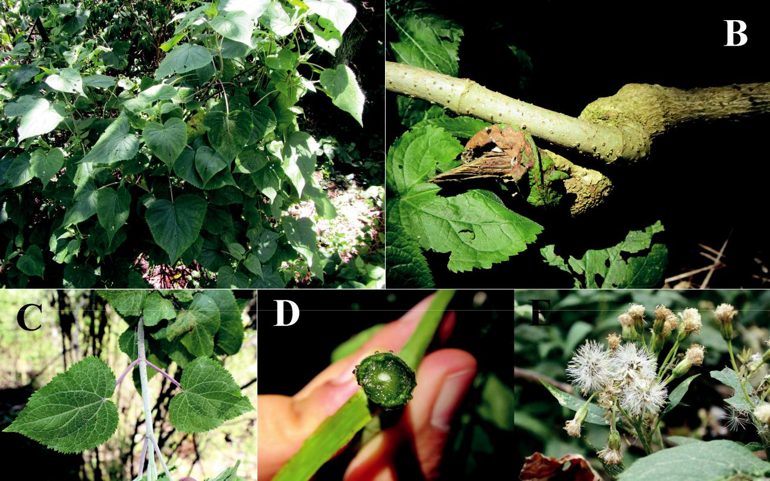

**Figure 1.** *Ageratina rivalis*. A. Young plant with widely ovate-cordate leaf blades. B. Lower woody branch with rounded, protruding lenticels. C.Young branch bearing opposite leaves. Note terete branch whitened by tomentulose or velutinous hairs and blades cordate at base. D. Internode cross section showing pith, cylindrical shape and protruding lenticels. E. Older heads.

dark-purplish spots, internodes hollow. Leaves decussate, pe-tioles 7–10 cm long, blades broadly ovate-deltate, the upper-most sometimes ovate, (4.5–) 9–28 × (3–) 10–29.5 cm, bases subcordate to truncate and tapering upon the petioles, the se-rrate-decurrent portion (0.5–) 2–6.5 cm long, margins irregu-larly serrate, apex acuminate, palmately veined from slightly above base. Heads 5–6 × 3–4 mm, clustered in tight corym-biform arrays that together form a paniculiform-corymbiform capitulescence; involucre 4–5 mm high, the bracts acute to acuminate, sparsely puberulent to pilose, covering almost all length of the corollas. Florets 28–32 per head, corollas 3–4

1. long, achenes 1.5–1.8 mm long. Pappus bristles 2.8–3.8 mm long (Figures 2, 4).

*Flowering*. (February-) March to June.

*Distribution*. Endemic to Mexico, only known from Ciudad

de México, Guerrero, Hidalgo, México, Michoacán, More-

los, and Oaxaca (Figure 5).

*Elevation*. 1,600–2,600 m.

*Habitat*. Shady places in slopes, ravines, banks, and road-sides, in humid mountain forest, *Pinus* forest and *Quercus* forest, often ruderal.

*Uses*. stomach discomfort (*Olaiz*, s.n. MEXU) and skin af-fections (*Soto 6372* MEXU).

*Common names*. “Axihuitl” (*Olaiz*, s.n. MEXU), “Copal”(*Hernández 4152* MEXU), “Quemada” (*Soto 6372* MEXU). *Specimens examined*. CIUDAD DE MEXICO: *Hinojosa 485* (MEXU); *Hinojosa 666* (MEXU); *Quijano s*.*n*. (MEXU). GUERRERO: *Kruse 2454* (MEXU); *Soto 8333* (MEXU); *Rzedowski 16393* (MEXU). HIDALGO: *Hernández 4152* (MEXU). MEXICO: *Boege 1745* (MEXU); *Matuda 30477* (MEXU); *Matuda 30754* (MEXU). MICHOACAN: *Cornejo* *3710* (MEXU); *Díaz 2105* (MEXU); *Kishler 564* (MEXU); *Soto 6333*, *6372* (MEXU); MORELOS: *Olaiz s*.*n*. (MEXU); *Dorado 1495* (MEXU); *Espín 31* (MEXU); *Espinosa 313* (MEXU); *Pringle 8050* (MEXU).

*Ageratina grandifolia* is unique in the subgenus *Ageratina* by its subhexagonal branches with hollow internodes and large leaf blades that are almost 30 cm long and wide (Figu-res 2, 4; Table 1), and notably serrate-decurrent at the base. *Ageratina rivalis* has similar leaf blades (almost 20 cm long),but these tend to be more cordate in shape and non-decurrent or with an entire decurrent portion if any. Other differences are summarized in Table 1. *Ageratina ramireziorum* (J. Es-pinosa) B.L. Turner is similar to *Ageratina grandifolia* in habit and head sizes (5-7 mm long). The leaf blades of the former can reach up to 15 cm long and 10 cm wide accor-ding to Espinosa (1984, 2001), and they are also similar in

253

Hinojosa-Espinosa *et al*. / Botanical Sciences 97 (2): 250-259. 2019

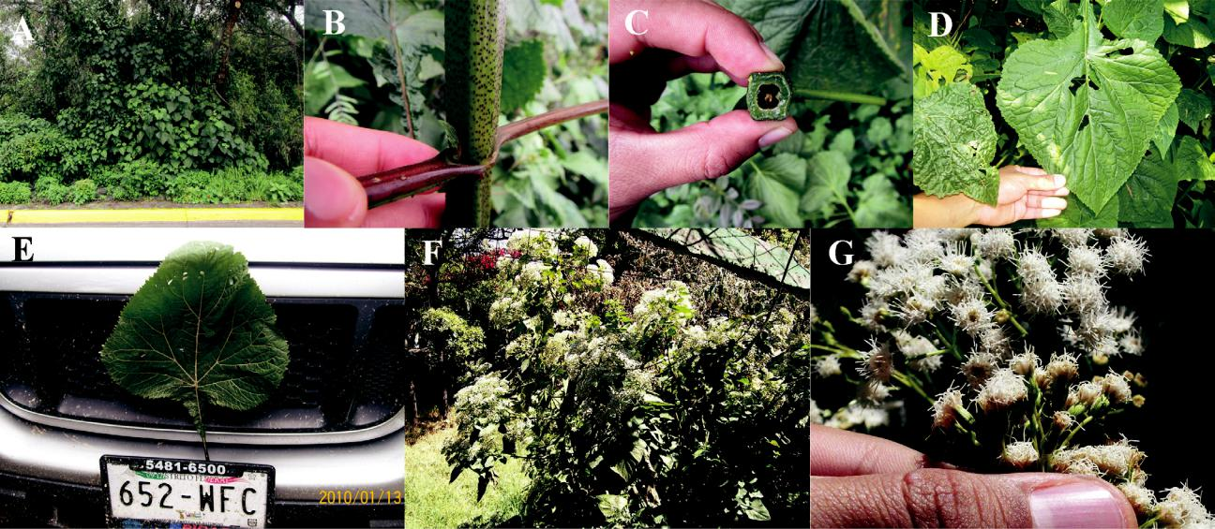

**Figure 2.** *Ageratina grandifolia*. A. Plant growing on a patch of “Ciudad Universitaria, UNAM” campus. B. Branch with purplish spots. C. Internodecross section showing hollow pith and subhexagonal shape. D and E. Widely ovate-deltate leaf blade with subcordate and serrate-decurrent bases. F. flowering plant on a disturbed terrain at Km 3 of highway Picacho-Ajusco, southern Mexico City. G. Heads with exerted style branches.

being cuneate to decurrent at the base, but different in their more ovate to rhombic-ovate shape. Moreover, the decurrent portion is not serrate.

According to the protologue of the basionym of *A*. *gran-difolia*, the plant was cultivated in Berlin from achenes thatwere found in a box that brought orchids from Guatemala; however, we could not find any records or herbarium sheets of this species from outside Mexico. So far, the southernmost records for this species are from Guerrero, Mexico, although Robinson (1926) cited it for the Sierra of San Felipe, in Oaxa-ca. The species was not cited from Mesoamerica (a region that includes southern Mexico and Central America) by King

* Robinson (1990) nor more recently by Pruski & Robinson (2018). Also, *A*. *grandifolia* is reported from Mexico City for the first time, where it may be introduced. The oldest record of *A*. *grandifolia* for Mexico City is the collection of *Quijano s*.*n*. (MEXU) made in 2006. It is not reported for theValley of Mexico (Espinosa 2001) nor in the checklist of the Asteraceae of “Pedregal de San Angel Ecological Reserve” (Céspedes *et al*. 2018). The species seems to be spreading in southern Mexico City, since we have observed individuals in several locations where they were absent previously. The species has been detected recently in basalt grounds on the campus of the National Autonomous University of Mexico, in the Bosque de Tlalpan National Park, and other sites in southern Mexico City (Figure 1).

*Ageratina rivalis.* (Greenm.) R.M. King & H. Rob., Phyto-logia 19: 216. 1970. Basionym: *Eupatorium rivale* Greenm., Zoë 5: 186. 1904. **Lectotype** (designated here)—Mexico: State of Mexico, Mt. Ixtaccihuatl, altitude 2,150 to 2,460 m, 1903, *Purpus 213* GH 00007363! (Figure 3); Isolectotypes: UC 86357!, MO 2151192!, US 00130515!.

*Eupatorium conspicuum* Kunth & Bouché, *Nom. Illeg*. var. *pueblense* B.L. Rob., Contr. Gray Herb. 68: 12. 1923.**Lec-totype** (designated here)—Mexico: State of Puebla, on rockyslopes, Boca del Monte, Mar 1908, *Purpus 2992* (the larger sample to the right of the herbarium sheet) UC 112962!.

*Ageratina skutchii* (B.L. Rob.) R.M. King & H. Rob., Phytolo-gia 19: 217. 1970. Basionym: *Eupatorium skutchii* B.L. Rob., Contr. Gray Herb. 104: 27. 1934. **Type**—Guatemala: Dept. Chimaltenango: open hillside, Santa Elena, alt. 2,400–2,700 m., Mar 25, 1933 *Skutch 337* (holotype: US 00145724!).

Shrubs or subshrubs, in clumps, up to 3 m tall, densely puberulent when young, but glabrescent and corky when old, young petioles and branches often tomentulose or velutinous. Stem branches terete, rounded when pressed, often with small rounded protruding lenticels, internodes solid. Leaves decussate, petioles (1–) 4–12.5 cm long, blades broadly ova-te-cordate to ovate, (6.5–) 10.5–17 × (4–) 8.5–15 cm, bases cordate to subcordate, sometimes rounded, rarely 1 cm tape-ring, margins irregularly serrate, apex acuminate, palmately veined from base or sometimes from slightly above the base in the uppermost leaves. Heads 7–10 × 4.5–6 mm, clustered in corymbiform arrays; involucre 5–6 mm, the bracts acute to acuminate, appressed-puberulent to glabrescent, covering half to almost all the length of the corollas. Florets 25–30 per head, corollas 4.5–5.5 mm, achenes 2–2.2 mm long. Pappus bristles 4.3–5.3 mm long (Figures 1 and 3).

*Flowering*. February to June.

*Distribution*. Mexico (Chiapas, Ciudad de México, Guerrero,Hidalgo, México, Michoacán, Morelos, Oaxaca, Puebla, and Veracruz) (Fig. 5), Guatemala and Honduras (Pruski & Rob-inson 2018).

254

On the identity of two Mexican species of *Ageratina*

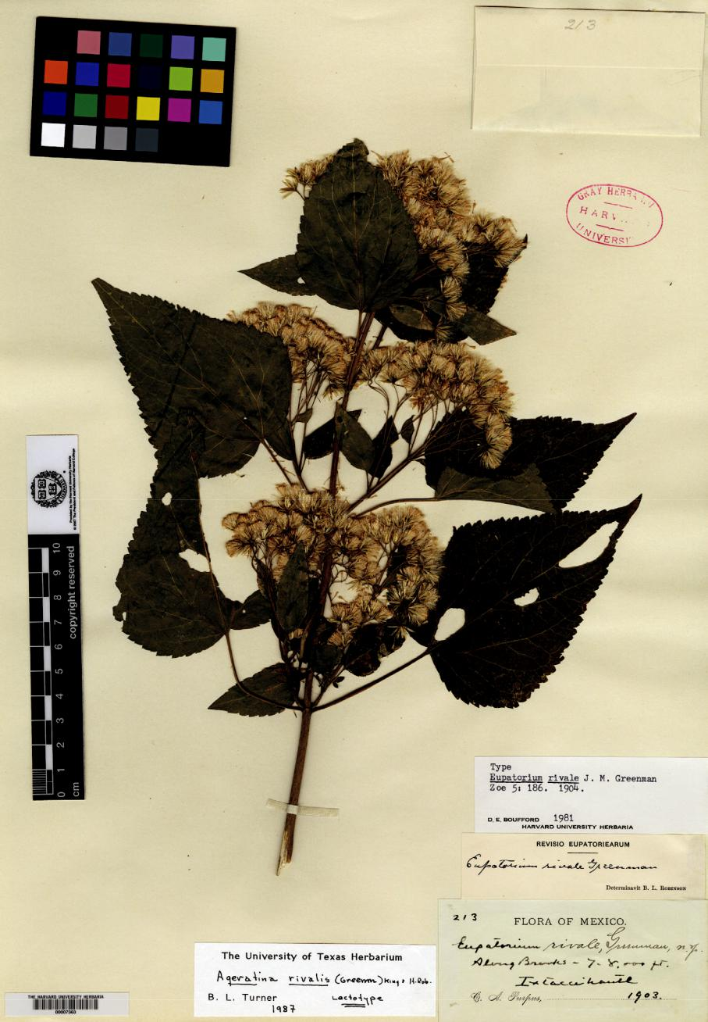

**Figure 3.** Lectotype of*Eupatorium rivale*Greenm. =*Ageratina rivalis*(Greenm.) R.M. King & H. Rob.

*Elevation*. 2,200 to 3,300 m. (MEXU); *Matuda 18808, 21023* (MEXU); *Rzedowski 15582*

*Habitat*. Shady places in slopes, ravines, clearings, and road- (MEXU); *Sandoval 12* (MEXU); *Ventura 1013* (MEXU).

sides, in mountain humid forest, *Pinus* forest, *Pinus*-*Oak* CHIAPAS: *Breedlove 9489* (MEXU); *Gómez 17* (MEXU);

forest, and *Abies* forest. *Martínez 22552* (MEXU); *Méndez 5801* (MEXU); *Villase-*

*Uses*. For cough (*Gómez 17* MEXU). *ñor 1224* (MEXU). GUERRERO: *Calónico 7091* (MEXU);

*Common names*. “Sak xaxib” (Tzeltzal) (*Gómez 17* MEXU), *Dorado 1515* (MEXU); *Panero 3949* (MEXU); *Torres 1048*

“Putzil momol” (Pruski & Robinson 2018). (MEXU). MEXICO: *Boyas 529* (MEXU); *Hinojosa 644,*

*Specimens examined*. CIUDAD DE MEXICO: *Espino-* (MEXU); *Lyonnet 2030, 3235* (MEXU); *Matuda 28279*

*sa 2* (MEXU); *Espinosa 23* (MEXU); *Hinojosa 492*, *645* (MEXU); *Miranda 4096* (MEXU); *Rzedowski 34659, 37719*

255

Hinojosa-Espinosa *et al*. / Botanical Sciences 97 (2): 250-259. 2019

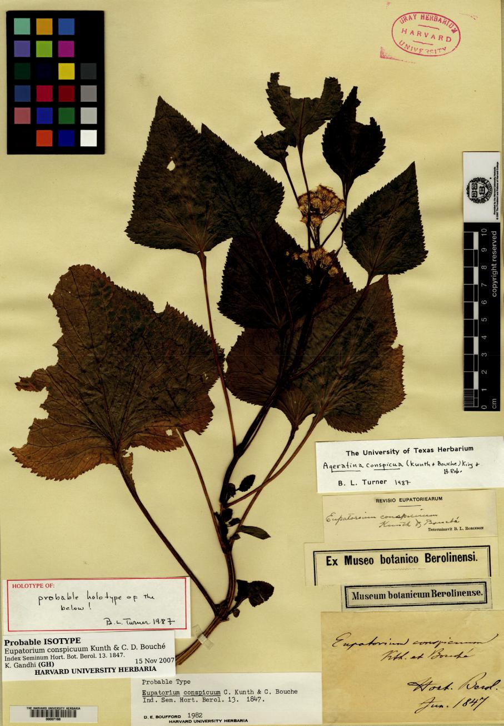

**Figure 4.** Lectotype of*Eupatorium conspicuum*Kunth & Bouché*Nom. Illeg*. =*Ageratina grandifolia*(Regel) R.M. King & H. Rob. Note angulateand sulcate branches as well as serrate-decurrent leaf blades. Compare with figure 2.

(MEXU); *Yahara 1288* (MEXU). MICHOACAN: *Álvarez* *15255*, *15185* (MEXU); *Cornejo 94* (MEXU); *Martínez 1445*, *1595b* (MEXU); *Soto 6351*, *18420*, *8450* (MEXU).MORELOS: *Salazar* s.n. (MEXU). OAXACA: *Calzada* *20782*, *22425* (MEXU); *Gallardo 1032* (MEXU). PUEB-LA: *Boege 2735* (MEXU); *Caamaño 6311* (MEXU). VERA-CRUZ: *Barrie 1347* (MEXU); *Nárave 406* (MEXU).

When Robinson (1923) published *E*. *conspicuum* Kunth & Bouche var. *pueblense* B.L. Rob. he was not aware that

the name *E*. *rivale* Greenm. (1907) had already been applied to this taxon, nor that the name *E*. *conspicuum* of Kunth

* Bouché (1847) was a later homonym of *E*. *conspicuum* Mart. ex Colla (1934). Later, Robinson (1926) treated *E*. *grandifolium* Regel as synonym of *E*. *conspicuum* of Kunth
* Bouché. When King & Robinson (1970) transferred se-veral species from *Eupatorium* to *Ageratina*, they also were not aware that their new combination, *Ageratina conspicua* (Kunth & Bouché) R.M. King & H. Rob., was based on an

256

On the identity of two Mexican species of *Ageratina*

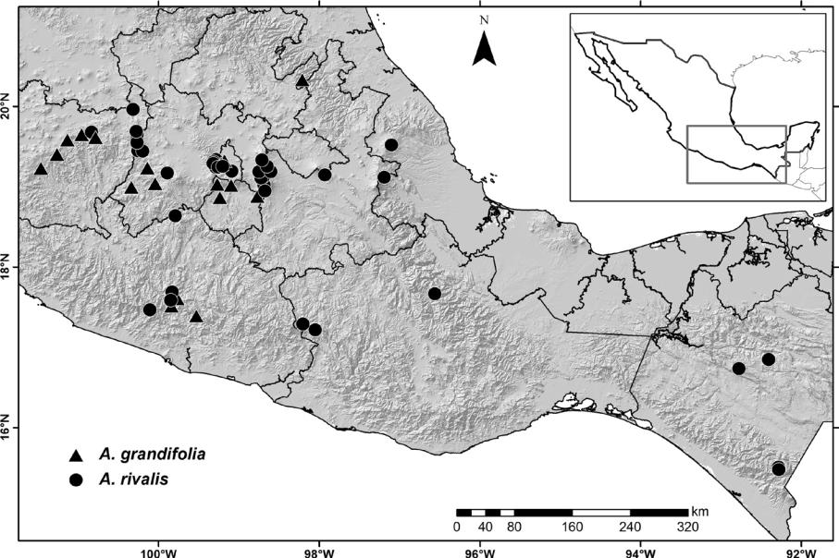

**Figure 5.** Geographical distribution of*Ageratina grandifolia*and*A*.*rivalis*in Mexico. The latter occurs also in Guatemala and Honduras.

illegitimate name. However, the name *A. conspicua* R.M. King & H. Rob. was effectively published as a replacement name for *E*. *conspicuum* of Kunth & Bouché. Later, King

* Robinson (1986) published *A. grandifolia* (Regel) R.M. King & H. Rob. thus, when these two taxa are conside-red taxonomic synonyms *A*. *grandifolia* has priority over *A*. *conspicua*.

In another matter, the herbarium sheet that here is desig-nated as lectotype for *Eupatorium rivale*, was also labelled as lectotype by Turner in 1989, but he never published it. Also, the specimen selected here as the lectotype for *E*. *conspicuum* var. *pueblense* at UC has a small branch of *A. pichinchensis* (Kunth) R.M. King & H. Rob. as Robinson (1923) noticed, and the fragment and photo at GH come from that branch of *A*. *pichinchensis*. Also, the duplicate at US is entirely a sample of *A*. *pichinchensis*. This species occurs at similar elevations than *A*. *rivalis* and flowers at the same season but has more pubescent stems and branches and its heads are smaller (5 mm long). Another similar species, *Ageratina* *isolepis* (B.L. Rob.) R.M. King & H. Rob. is a suffruticousherb that shares with *A*. *rivalis* the terete branches with small rounded lenticels, solid internodes, and rounded to subcorda-te leaf blade bases. The leaf blades can reach up to 11 and 17 cm long respectively. In addition, *A*. *isolepis* occurs at similar elevations than *A*. *rivalis* in the Valley of Mexico (Espinosa 2001), and both flower during the spring. However, *A*. *isole-pis* can be distinguished from *A*. *rivalis* by its shorter roundedinvolucral bracts (4-5 mm long), which cover half of the corollas, and smaller, more ovate to ovate-lanceolate leaves. *Ageratina ramireziorum* has also terete branches with solidinternodes. It occurs at similar elevations than *A*. *rivalis* and also flowers in the spring. However, the heads are slightly shorter (5-7 mm long) and the leaf blades are ovate to rhom-

bic-ovate. Turner (1997) states that both *A*. *ramireziorum* and *A*. *isolepis* may be the same species as *A*. *photina* (B.L. Rob.) R.M. King & H. Rob. Another species that sometimes is confused with these taxa is *A*. *pazcuarensis* (Kunth) R.M. King & H. Rob. This species is a perennial herb with ovate, non-decurrent leaf blades that flowers mostly on the fall and early winter. The heads of *A*. *pazcuarensis* seem to be similar in size (5-9 mm long) to those of *A*. *rivalis*. Last, we are follo-wing Pruski & Robinson (2018) in treating the Guatemalan *A*. *skutchii* (B.L. Rob.) R.M. King H. Rob., as synonym of *A*. *rivalis*; however, the whole complex requires further studyto clarify the circumscription of these species. Meanwhile, the following key may help to recognize *A*. *grandifolia* and *A*. *rivalis* from similar species.

*Key to Ageratina grandifolia, A. rivalis, and similar spe-cies*

1a. Branches subhexagonal with hollow internodes, clearly grooved or sulcate when pressed; leaf blades with the bas-es strongly serrate-decurrent into the petioles (Figures 2,

1. . . . . . . . . . . . . . . .*Ageratina grandifolia* 1b. Branches terete with pithy internodes, rounded or con-vex when pressed; leaf blades with the bases cordate to rounded or cuneate to entire-decurrent (but not serrate-de-current) . . . . . . . . . . . . . . . . . . . . (2)

2a. Stems copiously pilose to densely hirsutu-lous . . . . . . . . . . . . .*Ageratina pichinchensis* 2b. Stems sparsely pilose or puberulent to glabrous, some-times tomentulose or velutinous when young . . . . . (3) 3a. Involucral bracts covering up to half of the corollas, their apices rounded . . . . . . . . . . *Ageratina isolepis* 3b. Involucral bracts covering almost all corolla length, their apices acute to acuminate . . . . . . . . . . . . . (4)

257

Hinojosa-Espinosa *et al*. / Botanical Sciences 97 (2): 250-259. 2019

4a. Leaves subpenninerved, with 2–4 veins from above the base of a main vein; heads mostly 4–5 mm long. . . . . . . . . . . . . *Ageratina ramireziorum* 4b. Leaves trinervate to palmately veined, with 3-5 main veins from the base or from slightly above the base; heads mostly 6–10 mm long . . . . . . . . . . . . . . (5) 5a. Shrubs or subshrubs, usually in clumps, the branches with small rounded protruding lenticels; flowering mostly from March to April . . . . . . . . . . . *Ageratina rivalis* 5b. Perennial rhizomatous herbs, the branches herbaceous and without lenticels; flowering mostly from September to December *. . . . . . . . . . Ageratina pazcuarensis*

Last, there were other species that were considered synonyms of *A*. *grandifolia* (as *A*. *conspicua*) by Turner (1997); namely *A*. *purpusii* (Brandegee) R.M. King & H. Rob., *A*. *mariarum* (B.L. Rob) R.M. King & H. Rob., and *A*. *herrerae* R.M. King

* H. Rob. In the case of *A*. *purpusii*, which is endemic to Baja California Sur, it was actually recognized, keyed, and mapped as a distinct species by Turner (1997) and thus, the synonymy was probably a typo. Alternatively, Turner (1997) may have considered it a synonym of *A. conspicua* at first and later reversed, but omitted to eliminate the listing from under *A. conspicua*. As for *A. herrerae* and *A*. *mariarum* it seems best to recognize these two taxa as different species until the whole group is not revised. The former, which is endemic to Panama, has been recognized as a distinct species for the Flora of Mesoamerica (Pruski & Robinson, 2018). However, McVaugh (1984) stated that *A*. *mariarum* is per-haps conspecific to *A*. *arsenei* (B.L. Rob) R.M. King & H. Rob. Otherwise, *A*. *mariarum* is only known to the states of Jalisco, Nayarit, and Sinaloa.

This work is a contribution to the taxonomy and biogeo-graphy of the genus *Ageratina* in Mexico. This kind of works are desirable because the advances in the taxonomic and bio-geographic knowledge of the species will improve our ability to conserve, monitor, and use them. Mexico stands out by ha-ving around 60 % of all the c. 250 *Ageratina* species, and 137 of them are endemic (Villaseñor 2018). Moreover, we have found reports of some medicinal uses for *A. grandifolia* and *A*. *rivalis* that require further study. According to *Soto 6372* (MEXU), in the locality of “El Caracol,” near Morelia, Mi-choacán, a medicinal poultice is made with chopped leaves of *A*. *grandifolia*. This is relevant, since antibacterial substancesand wound healing extracts have been obtained from other Mexican species that have been used in traditional medicine, such as *A. arsenei* (García-Sánchez *et al*. 2015) and *A*. *pi-chinchensis* (Romero-Cerecero *et al*. 2012). Furthermore, theprotologue of *A*. *grandifolia* and its synonyms indicate this species was grown in the botanic garden of Berlin during the XIX century for its attractive capitulescences (Figure 2F-G). Therefore, this species has a potential as ornamental. On the other hand, other species such as *A*. *adenophora* R.M King

* H. Rob. and *A*. *riparia* R.M. King H. Rob., are known to be problematic invasive plants elsewhere (Weber 2017). For-tunately, this has not been a problem for Mexico, although here we report the possible introduction and spreading of *A*. *grandifolia* in southern Mexico City. Accurate species

determination is required to identify weed introductions and monitor their spreading. We hope this work, in which we clarify the morphology, nomenclature, and distribution of *A*. *grandifolia* and *A*. *rivalis*, and discuss how to distinguishthem from similar species, is helpful for their identification.

**Acknowledgements**

We thank MEXU staff for letting us consult their collections and staff from Gray Herbarium at Harvard University for pro-viding high quality pictures of type material and allow us to use them in this publication. We also thank Daniel Potter for reviewing an earlier version of the manuscript and providing valuable comments, including English corrections. We are especially thankful to Ellen Dean for her help with finding type material and protologues, and for correcting the English of the submitted version. Last, we thank Sandra Knapp, Jef-ferson Prado, Nicholas Turland, and the students who took the nomenclature workshop during the XII Latin American Botanical Congress at Quito, Ecuador, for their help with the clarification of the nomenclature of the species. We are especially thankful to Jefferson Prado, Nicholas Turland and Daniel Potter for their help with the nomenclature problems. Finally, we thank the two anonymous reviewers for their ap-propriate comments, observations, and corrections.

**Literature cited**

Bremer K, Anderberg AA, Karis PO, Lundberg J. 1994. Eupa-torieae. *In*: Bremer K, ed. *Asteraceae, Cladistics and Clas-sification*. Portland, USA: Timber Press, 625-680. ISBN-13:978-0881922752

Céspedes L, Ortiz E, Villaseñor JL. 2018. La familia Asteraceae en la Reserva Ecológica del Pedregal de San Ángel, Ciudad de México, México. *Revista Mexicana de Biodiversidad* **89**: 193-207.

DOI: http://dx.doi.org/10.22201/ib.20078706e.2018.1.2203 Espinosa GJ. 1984. Dos nuevas especies de *Eupatorium* (Com-positae) del Valle de México. *Phytologia* **56**: 331-336. Espinosa J. 2001. *Eupatorium*. *In*: Calderón de Rzedowski G,

Rzedowski J, eds. *Flora fanerogámica del Valle México*. Instituto de Ecología y Comisión Nacional para el Cono-cimiento y Uso de la Biodiversidad, 786-800. ISBN: 978-607-7607-36-6

García-Sánchez E, Ramírez-López CB, Martínez-Muñoz RE, Flores-García A, Del Río RE, Martínez-Pacheco MM. 2015. Antibacterial activity of some medicinal *Eupatorium* species against antibiotic resistant pathogenic bacteria. *Polibotánica* **39**: 91-101.

Global Plants. 2018. <https://plants.jstor.org/> (accessed: Sep-tember 2018)

Ito M, Yahara T, King RM, Watanabe K, Oshita S, Yokoyama J, Crawford DJ. 2000. Molecular phylogeny of Eupatorieae (Asteraceae) estimated from cpDNA RFLP and its implica-tion for the polyploid origin hypothesis of the tribe. *Journal* *of Plant Research* **113**: 91-96.

DOI: https://doi.org/10.1007/PL00013919

King RM, Robinson H. 1970. Studies in the Eupatorieae (Com-

258

On the identity of two Mexican species of *Ageratina*

positae). XIX. New combinations in *Ageratina*. *Phytologia* **19**: 208-229.

King RM, Robinson H. 1986. Studies in the Eupatorieae (As-teraceae) CCXXII. New combinations and new species from Tropical America. *Phytologia* **60**: 80-86.

King RM, Robinson H. 1987. *The genera of the Eupatorieae* *(Asteraceae)*. Sant Louis Missouri: Missouri Botanical Gar-den Press.

King RM, Robinson H. 1990. Notes of *Ageratina* in Mesoame­ rica (Eupatorieae: Asteraceae). *Phytologia* **69**: 61-86.

McVaugh R. 1984. Flora Novo-Galiciana. *A descriptive account* *of the vascular plants of Western Mexico, Compositae*. AnnHarbor, Michigan: The University of Michigan Press. ISBN-13: 978-0472048120

Panero JL, Villaseñor JL. 1998. A new species of *Ageratina* (As-teraceae: Eupatorieae) from Northwestern Oaxaca. *Lundellia* **1**: 72-74. DOI: https://doi.org/10.25224/1097-993X-1.1.72

Pruski JF, Robinson H. 2018. Asteraceae. *In*: Davidse G, Sousa-Sánchez M, Knapp S, Chiang-Cabrera F, eds*. Flora Meso-americana*. Sant Louis Missouri: Missouri Botanical GardenPress. ISBN: 978-0915279982

Robinson BL. 1923. Records preliminary to a general treatment of the Eupatorieae,—III. *Contributions from the Gray Her-barium* **68**: 3-43.

Robinson BL. 1926. *Eupatorium*. *In*: Standley PC. Trees and shrubs of Mexico (Bignoniaceae-Asteraceae). *Contributions* *from the United States National Herbarium* **23**: 1432-1469.

Robinson H, Schilling EE, Panero JL. 2009. Eupatorieae. *In*: Funk VA, Susanna A, Stuessy TF, Bayer RJ, eds. *Systemat-ics*, *Evolution and Biogeography of the Compositae*. Vien-na: International Association for Plant Taxonomy, 731-744. ISBN: 978-3950175431

Romero-Cerecero O, Zamilpa-Álvarez A, Jiménez-Ferrer E, Tortoriello J. 2012. Exploratory study on the effectiveness



**Associated editor:** Enrique Jurado.

**Author Contributions:** OHE: identified the problem, wrote themanuscript, analyzed the characters of the species and collected additional material. JLV: wrote along with OHE the manuscript and analyzed the characters of the species. EO: helped with the elaboration of the manuscript, organized the database of the records, and made the digital cartography.

of a standardized extract from *Ageratina pichinchensis* in patients with chronic venous leg ulcers. *Planta Medica* **78**: 304-310. DOI: https://doi.org/10.1055/s-0031-1280448

Schilling EE, Panero JL, Cox PB. 1999. Chloroplast DNA re-striction site data support a narrowed interpretation of *Eupa-torium* (Asteraceae). *Plant Systematics and Evolution* **219**:209-223. DOI: https://doi.org/10.1007/BF00985580

Turner BL. 1997. The Compositae of Mexico. A systematic account of the family Asteraceae, volume 1. Eupatorieae. *Phytologia Memoirs* **11**: 1-272.

Turner BL. 2006. Three New Species of *Ageratina* (Asteraceae: Eupatorieae) from Oaxaca, Mexico and a key to the *A*. *maire-tiana* Complex. *Lundellia* **9**:1-6.

DOI: https://doi.org/10.25224/1097-993X-9.1.1

Turner BL. 2007. Two new species of *Ageratina* (Asteraceae:

Eupatorieae) from Mexico. *Phytologia* **89**: 193-197.

Turner BL. 2008. Seven new species of *Ageratina* (Asteraceae, Eupatorieae) from Mexico. *Phytologia* **90**: 358-375.

Turner BL. 2012. A new species of *Ageratina* (Asteraceae: Eu-patorieae) from Sinaloa, Mexico. *Phytoneuron* **91**: 1-4. DOI: https://doi.org/10.2307/3670769

Villarreal-Quintanilla JA. 2001. *Listados florísticos de México* *XXIII. Flora de Coahuila.* México D.F.: Instituto de Bio­logía, Universidad Nacional Autónoma de México. ISBN: 968-36-9771-2

Villaseñor JL. 2016. Checklist of the native vascular plants of Mexico. *Revista Mexicana de Biodiversidad* **87**: 559-902. DOI: https://doi.org/10.1016/j.rmb.2016.06.017

Villaseñor JL. 2018. Diversidad y distribución de la familia Asteraceae en México. *Botanical Sciences* **96**: 332-358. DOI: http://dx.doi.org/10.17129/botsci.1872

Weber E. 2017. *Invasive Plant Species of the World: a Refer-ence Guide to Environmental Weeds*. Boston, Massachusetts:CAB International. ISBN-13: 978-1780643861

259